29th October 2019

**Three races, 3 winners: Very competitive WTCR season delivers at Suzuka**

The FIA WTCR (World Touring Car Cup) which has the Japanese Premium tyre manufacturer YOKOHAMA as exclusive tyre partner was full of excitement at the weekend in Japan with rounds 22, 23 and 24 of 30 taking place at the legendary Suzuka Circuit.

Current leader Guerrieri won Race 1 for Honda whilst BRC Hyundai’s Michelisz scored his fourth victory of 2019 with a triumph on race 2. For his part Kristoffersson was once again celebrating victorious in the Volkswagen-powered Sébastien Loeb Racing team.

After languishing in P10 in Race 2, Honda-powered Guerrieri – competing at the Japanese make’s home track – hit back to follow Kristoffersson (SLR Volkswagen) home in Race 3. Those points, added to his Race 1 victory, brings the ALL-INKL.COM Münnich Motorsport driver to top the standings with a six-point advantage over Norbert Michelisz, who took the Race 2 win for BRC Hyundai N Squadra Corse.

Kevin Ceccon completed the Race 3 podium in unusual circumstances when he benefited from a “miscommunication” by Tiago Monteiro. The Portuguese, thinking the race had run its course under the safety car, headed to the pits in error from third. While he quickly realised his mistake, it was too late to the extent Team Mulsanne’s Ceccon and Cyan Racing Lynk & Co’s Thed Björk had moved ahead.

By re-passing Björk, Monteiro received a 10-second time penalty for overtaking under the safety car and slipped to P15 in the final order. Ceccon, meanwhile, was demoted to sixth after he picked up a five-second penalty for a clash with Rob Huff earlier in the race. Björk therefore inherited third with Gabriele Tarquini moving up to fourth and Andy Priaulx taking fifth following his hefty Race 1 crash. With 24 races run, Björk is third in the standings.

Huff scored his first 2019 podium with second place in Race 2 at the wheel of his SLR VW Motorsport Volkswagen Golf GTI R5 as Tarquini held off the charging Ceccon for third.

The next race meeting will be held in the spectacular Macau street circuit of Guia from 14th to 17th November 2019.

Current standings;

1. Guerreri 288pts

2. Michelisz 282pts

3. Björk 248pts

4. Muller 240pts

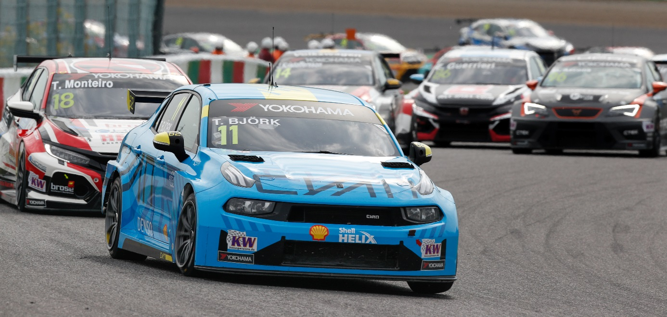

*04-Thed-Bjork.jpg Photo by Frederic Le Floch*

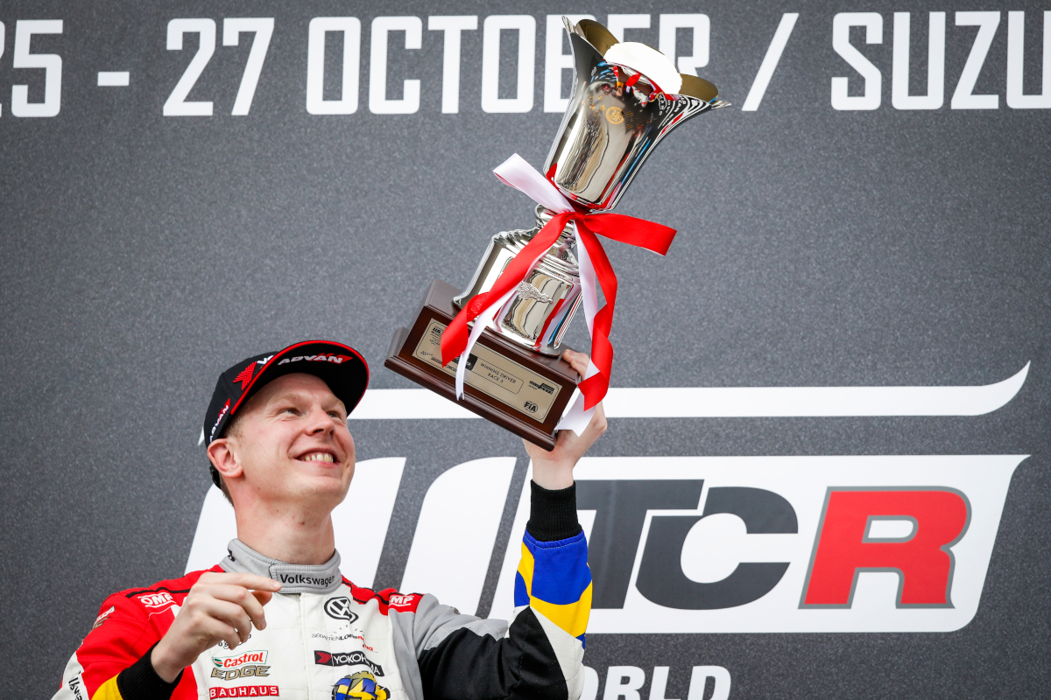

*05-Johan-Kristoffersson2.jpg Photo by Florent Gooden*